Multiple chart

The chart above shows information about various professions in the U.K. and their salaries. The table shows the average working hours per week for each profession.

Summarise the information by selecting and reporting the main features, and make comparisons where relevant.

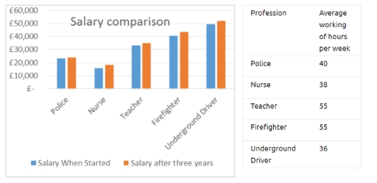

The provided graph presents data on various professions and their income levels in the United Kingdom, while the table illustrates the average number of hours worked per week in each occupation.

Overall, the bar graph clearly shows that the majority of occupations experience a wage increase after three years of experience in the UK. However, the table reveals that firefighters and teachers work significantly more hours per week than other professions.

According to the bar chart, underground drivers have the highest starting income at £50,000, followed by firefighters at £40,000; both see an increase of £1,000 after three years. Conversely, nurses have the lowest starting income at £18,000, which rises to £19,000 after three years. Lastly, police officers experience the most substantial salary increase of £2,000, reaching a total of £23,000 after three years of experience.

The table shows that teachers and firefighters work the most, with 55 hours per week, while underground drivers have the shortest workweek at just 36 hours. Police officers and nurses work 40 and 38 hours per week, respectively.